**How to modify Existing Slider Image:**

Step 1: Click The **Content** Option in header section

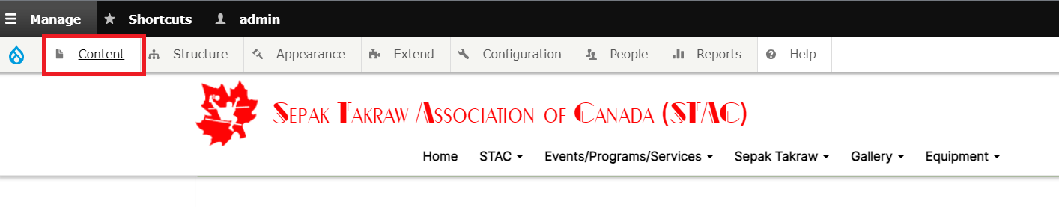

Step 2: After clicking content below page will open

Step 3: In content type section you would choose Slider Images in Drop Down list

Step 4: After choosing Slider Image from Drop down list, you want to click Filter button

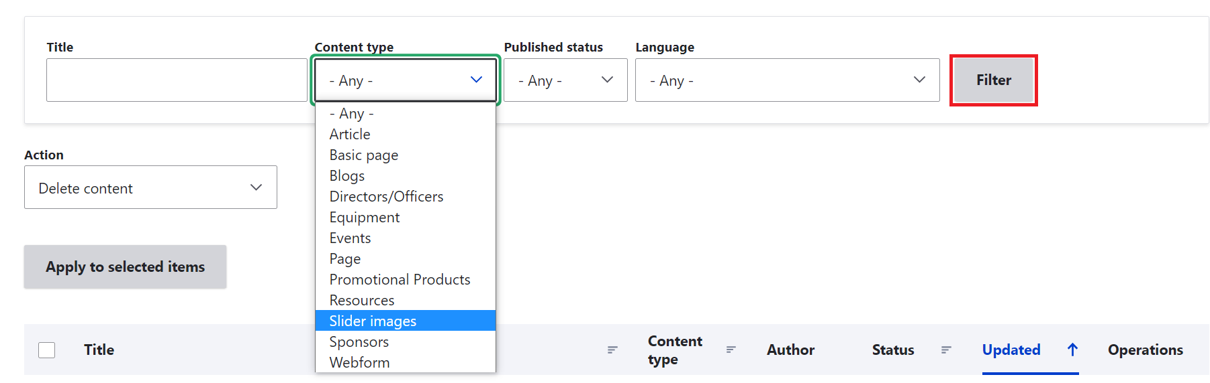

Step 5: After clicking filter button the list of available slider image is shown like below image

Step 6: Choose which slider you want to edit and click **Edit** button in the right corner

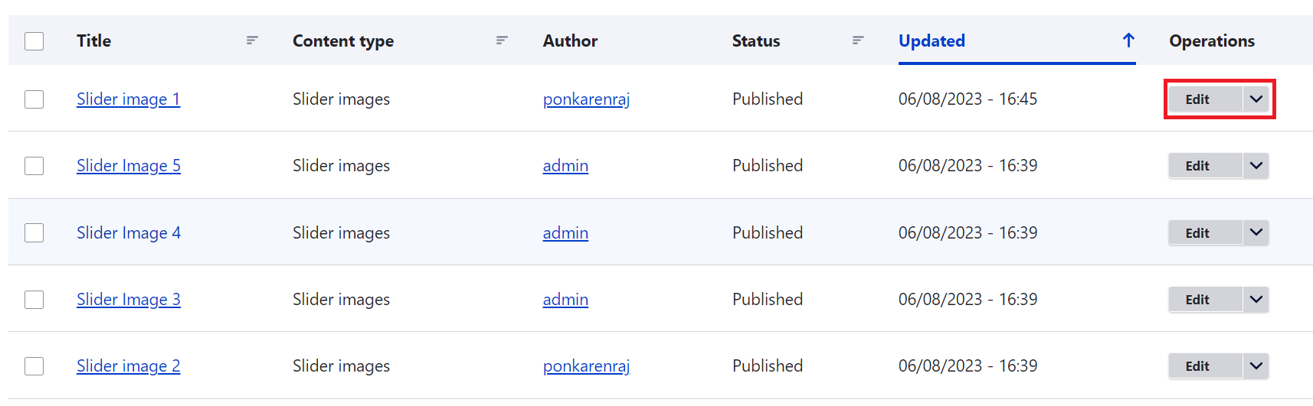

Step 7: After clicking Edit button, the below page will show, if you want modify slider name change name in **Slider** section

Step 8: If you want change Slider Image click **Remove** button

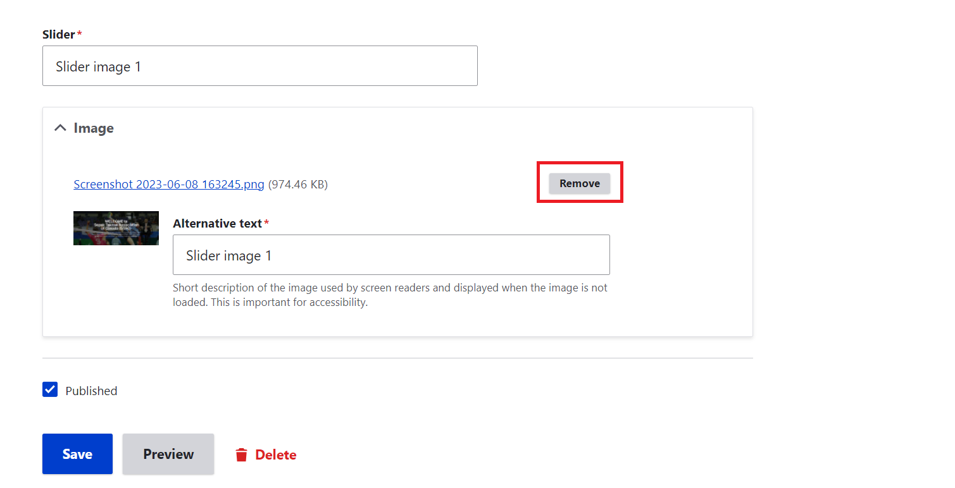

Step 9: If you want to add a new pictures, click **Choose file** button, after that it will redirected to your PC and choose pictures that you want to add

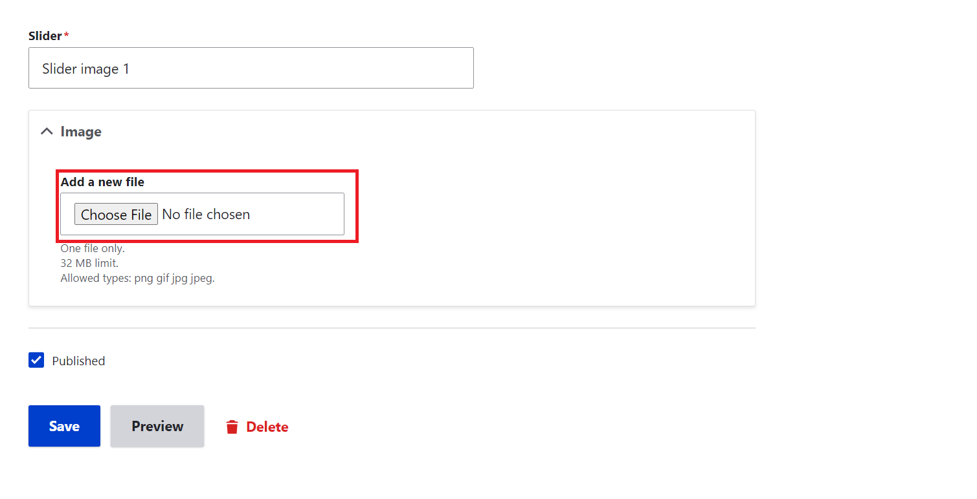

Step 10: After choosing Pictures click **save** button

**How to Add New Slider Image:**

Step 1: Click The **Content** in dropdown list click **Add content** Option in header section

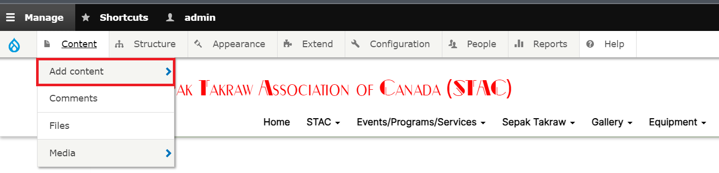

Step 2: After clicking Add content below page will be open

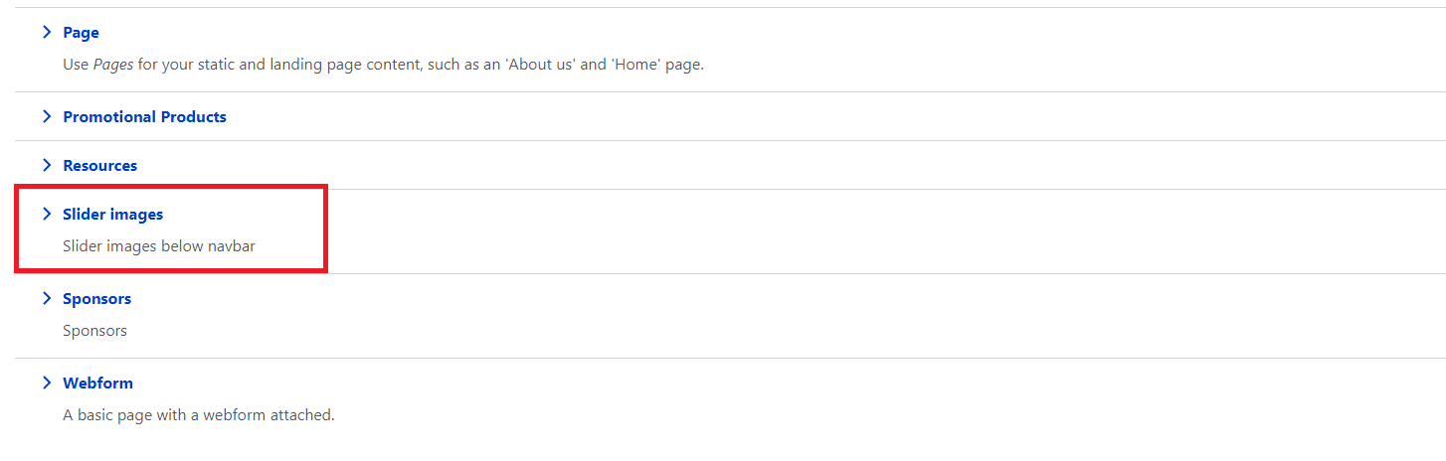

Step 3: As above image you want to click Slider image option

Step 4: After choosing Slider image option below Page will be open

Step 5: Enter Slider name in slider option and after click **choose file** button to add a new pictures, after that it will redirected to your PC and choose pictures that you want to add

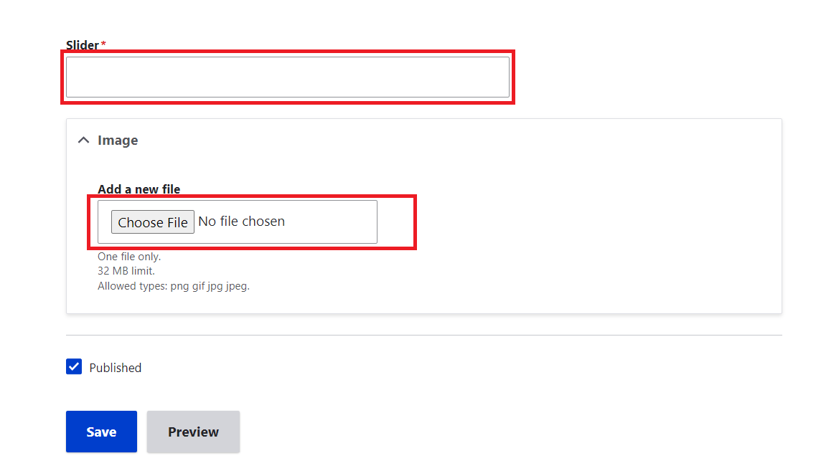Step 6: After choosing Picture click **Save** button

**How to modify Existing Sponsor Image:**

Step 1: Click The **Content** Option in header section



Step 2: After clicking content below page will open

Step 3: In content type section you would choose Sponsors in Drop Down list

Step 4: After choosing sponsors from Drop down list, you want to click Filter button

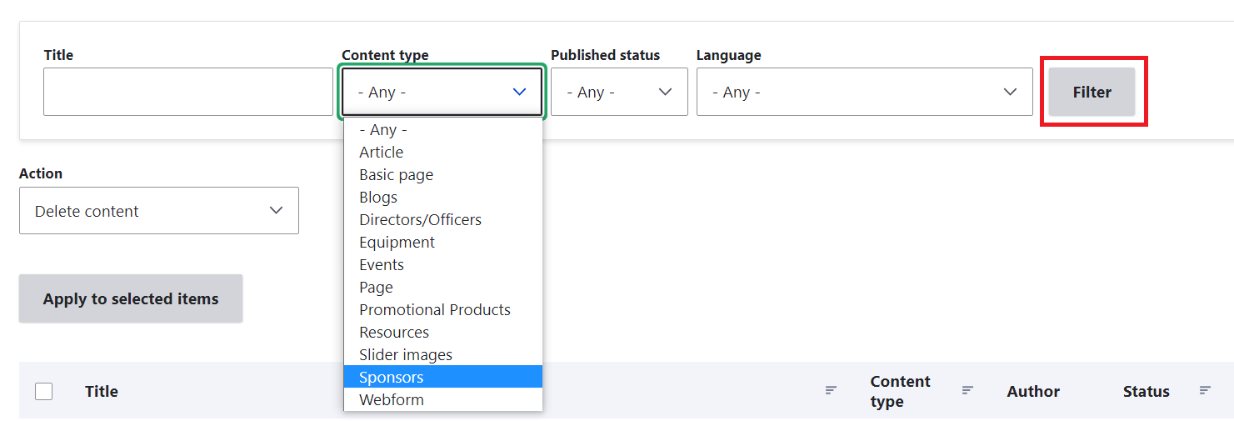

Step 6: After clicking filter button the list of available sponsors is shown like below image

Step 7: Choose which sponsor you want to edit and click **Edit** button in the right corner

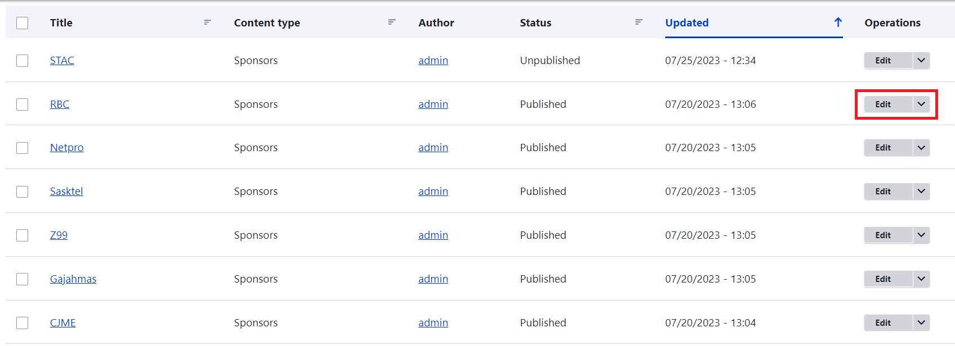

------------------------------------------------------------------------------------------------------------------------------------------

**How to modify Existing Blogs:**

Step 1: Click The Content Option in header section



Step 2: After clicking content below page will open

Step 3: In content type section you would choose **blogs** in Drop Down list

Step 4: After choosing blogs from Drop down list, you want to click **Filter** button

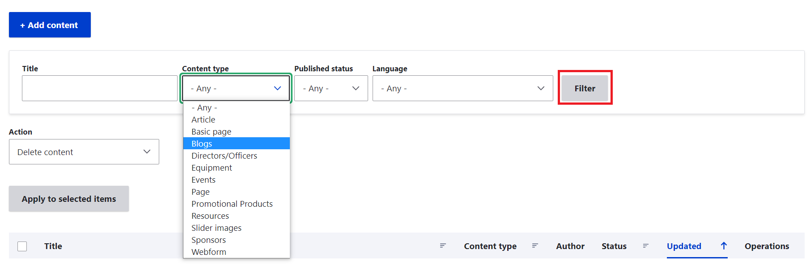

Step 5: After clicking filter button the list of available blogs is shown like below image

Step 6: Choose which blog you want to edit and click Edit button in the right corner

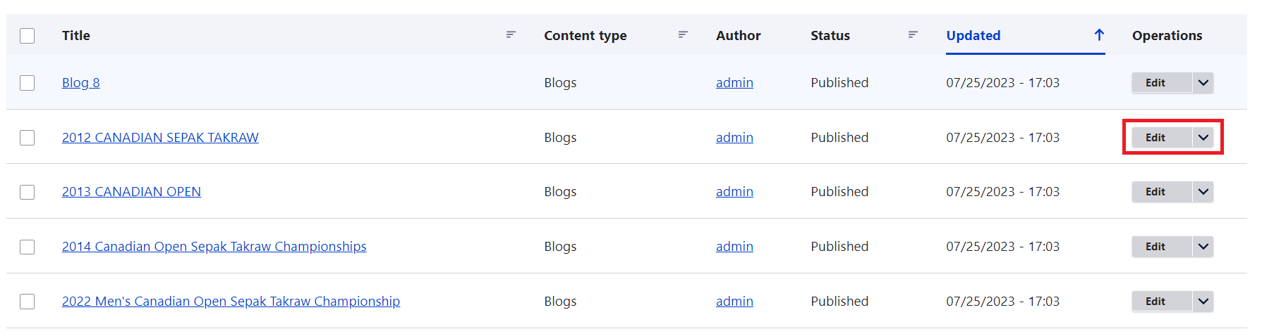

Step 7: After clicking Edit button, the below page will show, if you want modify blog title change title in title section

Step 8: If you want to change existing blogs.in **Body** section in right corner click **source** button

Step 9: After clicking Source, in Body section you want to change contents in the paragraph tags only.

(Note: Don’t remove any class in body section, Incase if you remove class CSS properties won’t work.)

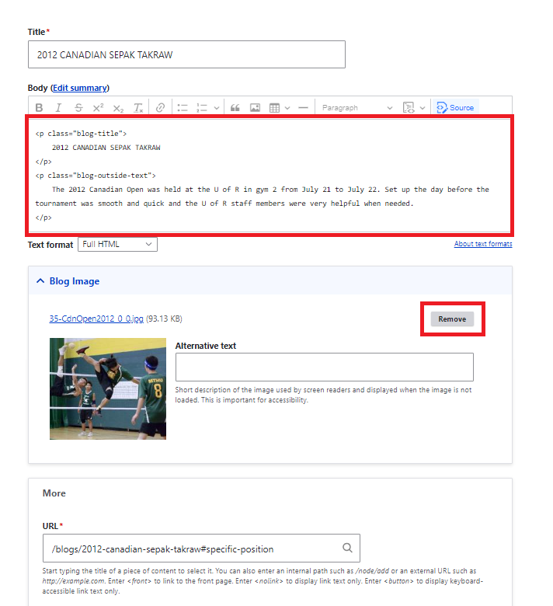

Step 10: If you want to change **blog image**, In Blog image section click **remove** button in the right corner

Step 11: Add new pictures by using **choose file** option in Blog image section

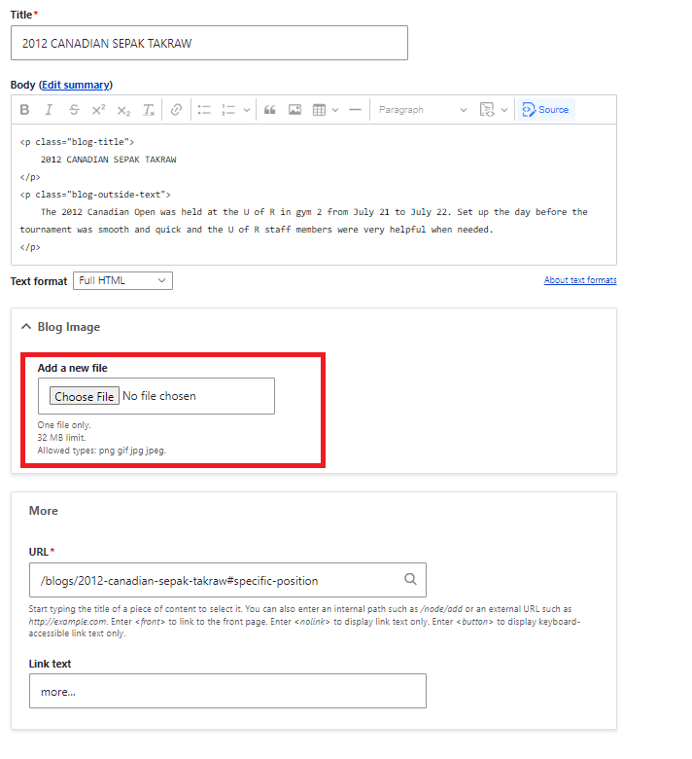

Step 12: After changes click **save** button in below of the page.

**How to Add Blogs:**

Step 1: Click The Content in dropdown list click Add content Option in header section



Step 2: After clicking Add content below page will be open

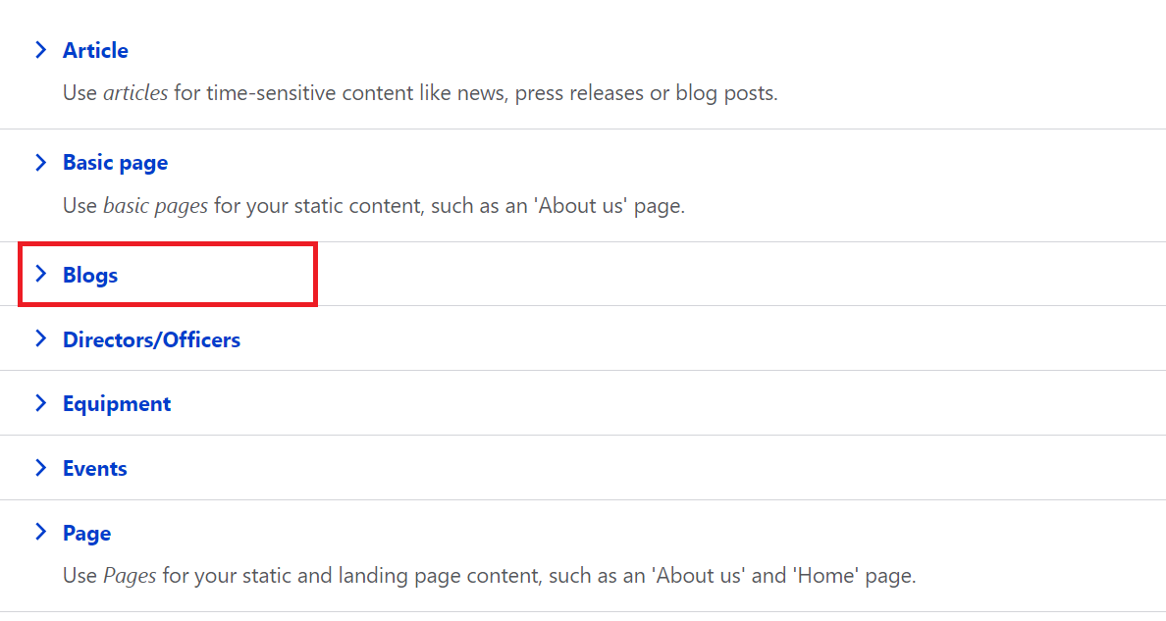

Step 3: As above image you want to click blogs option

Step 4: After choosing blogs option below Page will be open

Step 5: Enter blog name in title section and after click source in body option enter the blogs that you want to add in paragraph tag

(Note: If you are adding new blogs please existing blogs once and refer html classes and tags.)

Step 6: To add a new blog image, click **choose file** in blog image section after click choose file button to add a new pictures, after that it will redirected to your PC and choose pictures that you want to add

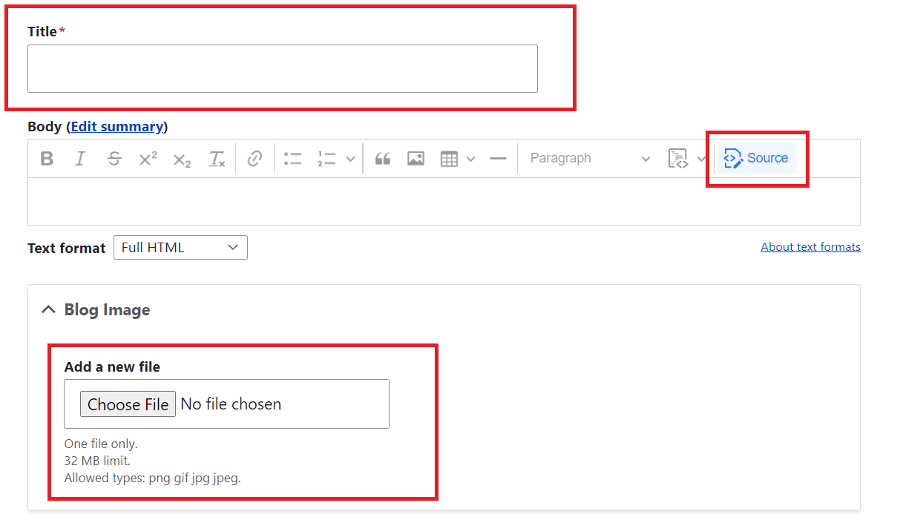

Step 7: After changes click **save** button in below of the page.

**How to edit basic pages:**

Step 1: Click The STAC menu option in header section

Step 2: click Organizational profile in Drop down list

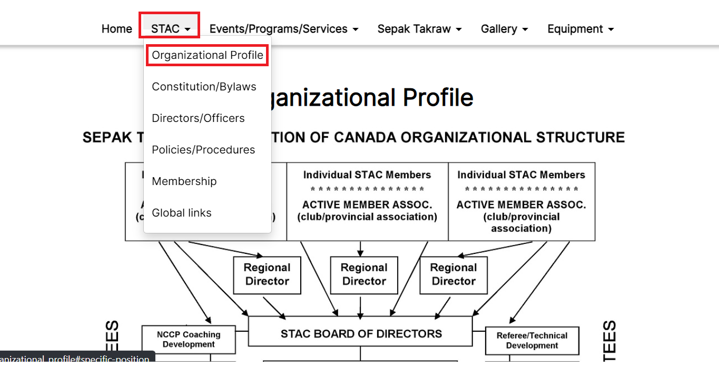

Step 3: Drag a mouse pointer to right corner of the block, click **pencil** icon and click **Edit** button

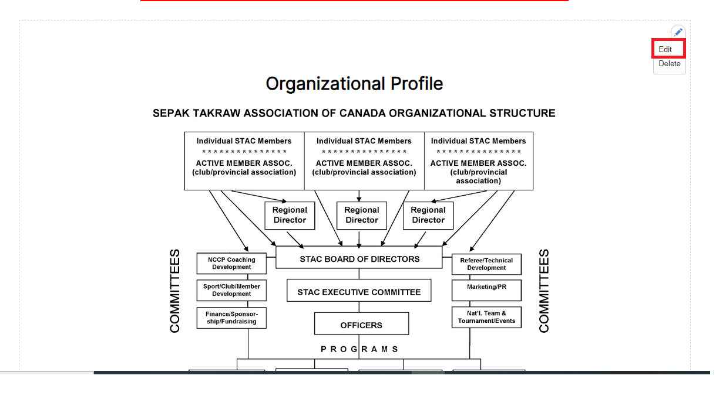

Step 2: After clicking Edit below page will be open

Step 3: As above image you want to click Slider image option

Step 4: Enter title name in title section and after that in body section enter the blogs that you want to change or add in paragraph tag

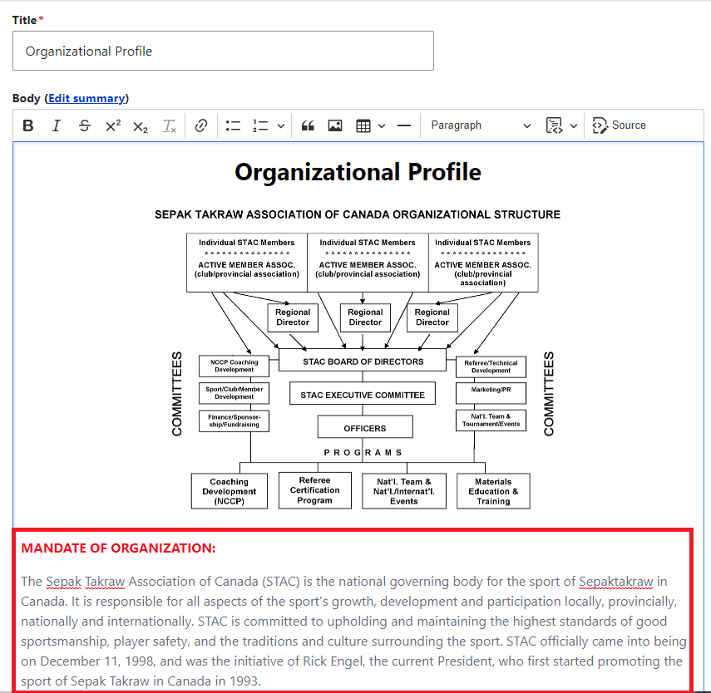

Step 5: After changes click **save** button in below of the page.

**How to modify existing directors list:**

Step 1: Click The **Content** Option in header section



Step 2: After clicking content below page will open

Step 3: In content type section you would choose **Directors/Officers** in Drop Down list

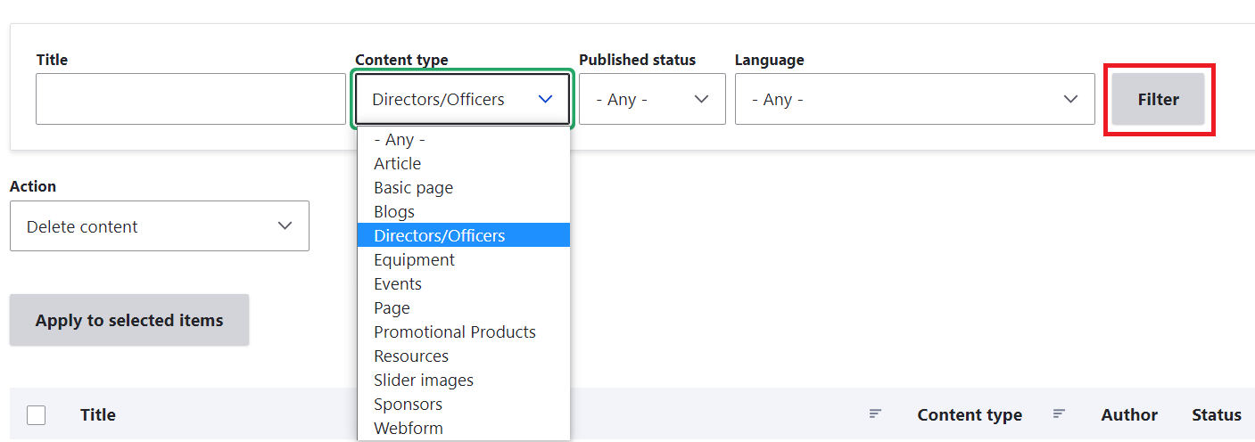

Step 4: After choosing **Directors/Officers** from Drop down list, you want to click Filter button

Step 5: After clicking **filter** button the list of available directors is shown like below image

Step 6: Choose which director you want to edit and click **Edit** button in the right corner

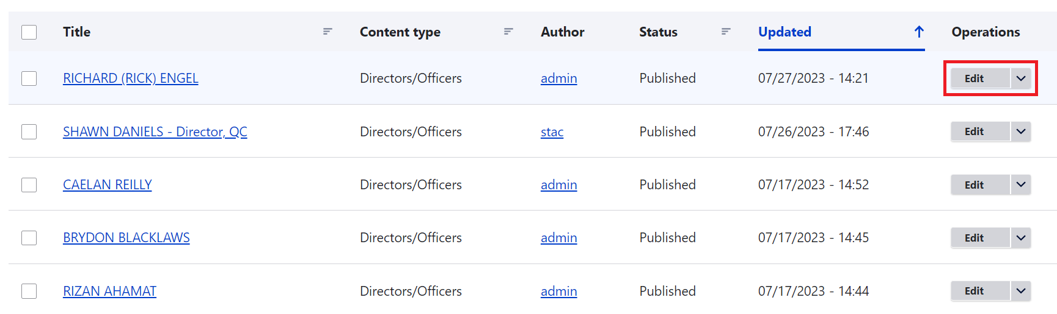

Step 7: After clicking **Edit** button, the below page will show, if you want modify title name change name in title section

Step 8: Enter title name in title section and after that in body section enter the blogs that you want to change or add in paragraph tag

Step 9: If you want to add a new pictures, click **Choose file** button, after that it will redirected to your PC and choose pictures that you want to add

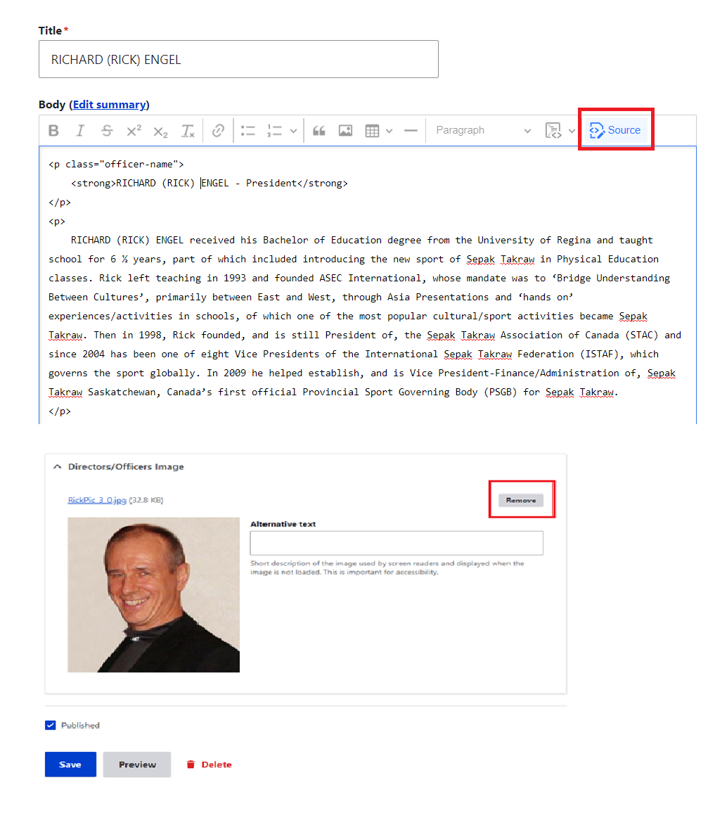

Step 10: After choosing Pictures click **save** button

**How to Add Directors:**

Step 1: Click The **Content** Option in header section



Step 2: After clicking content below page will open

Step 3: Click **Directors/officers**

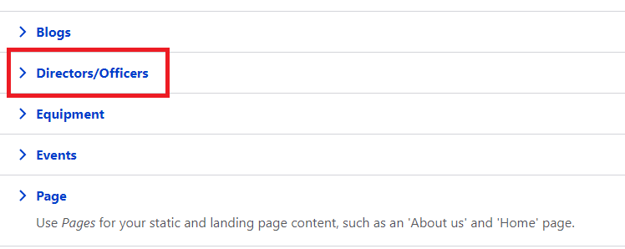

Step 4: After clicking content below page will open

Step 5: Enter title name in title section, and after that in body section enter the blogs that you want to change or add in paragraph tag

(Note: If you are adding new blogs please validate existing blogs once and refer html classes and tags.)

Step 6: To add a new Directors/officers image, click **choose file** in **Director/officer** image section after click **choose file** button to add a new pictures, after that it will redirected to your PC and choose pictures that you want to add

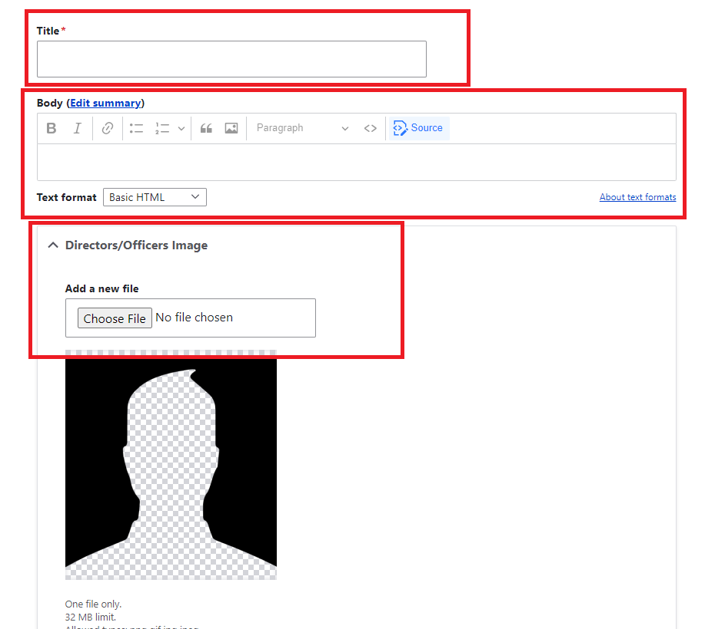

Step 10: After choosing Pictures click **save** button

**How to Modify Existing Resources:**

Step 1: Click The **Content** Option in header section



Step 2: After clicking Add content below page will be open

Step 3: select **resources** from drop down list

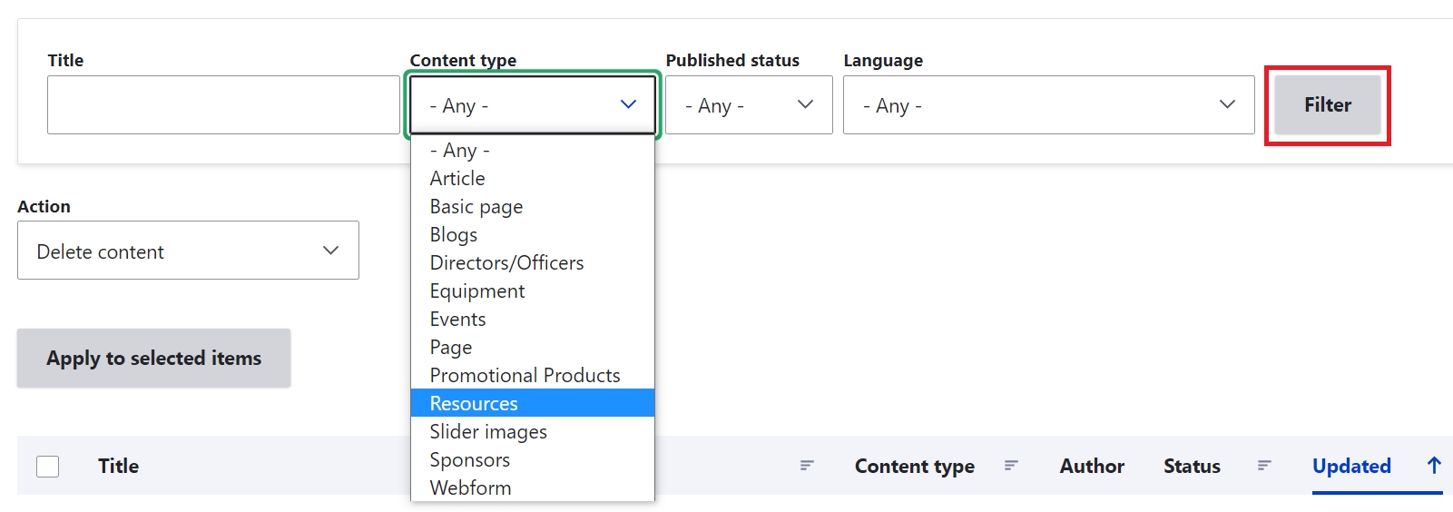

Step 3: After clicking filter button the list of available resources is shown like below image

Step 4: Choose which resource you want to edit and click Edit button in the right corner

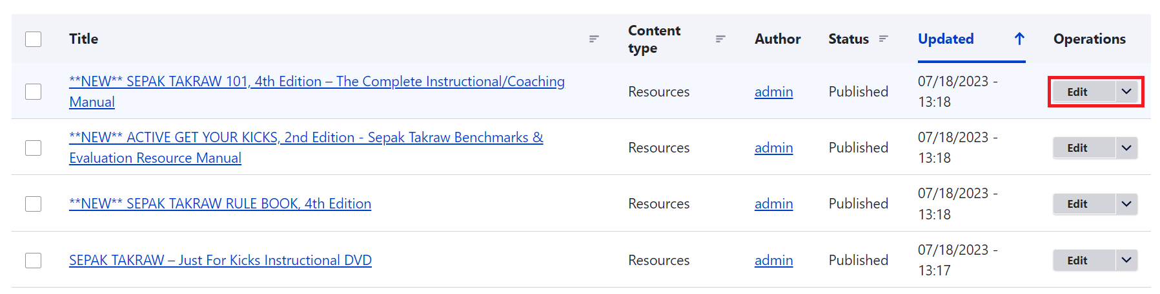

Step 5: After clicking Edit button, the below page will show

Step 6: Enter title name in title section, and after that in body section enter the directors blogs that you want to change or add in paragraph tag

(Note: If you are adding new blogs please validate existing directors once and refer html classes and tags.)

Step 6: To add a resource image, click remove button in the right corner.

Step 7: After that click **choose file** in resource image section after click **choose file** button to add a new pictures, after that it will redirected to your PC and choose pictures that you want to add

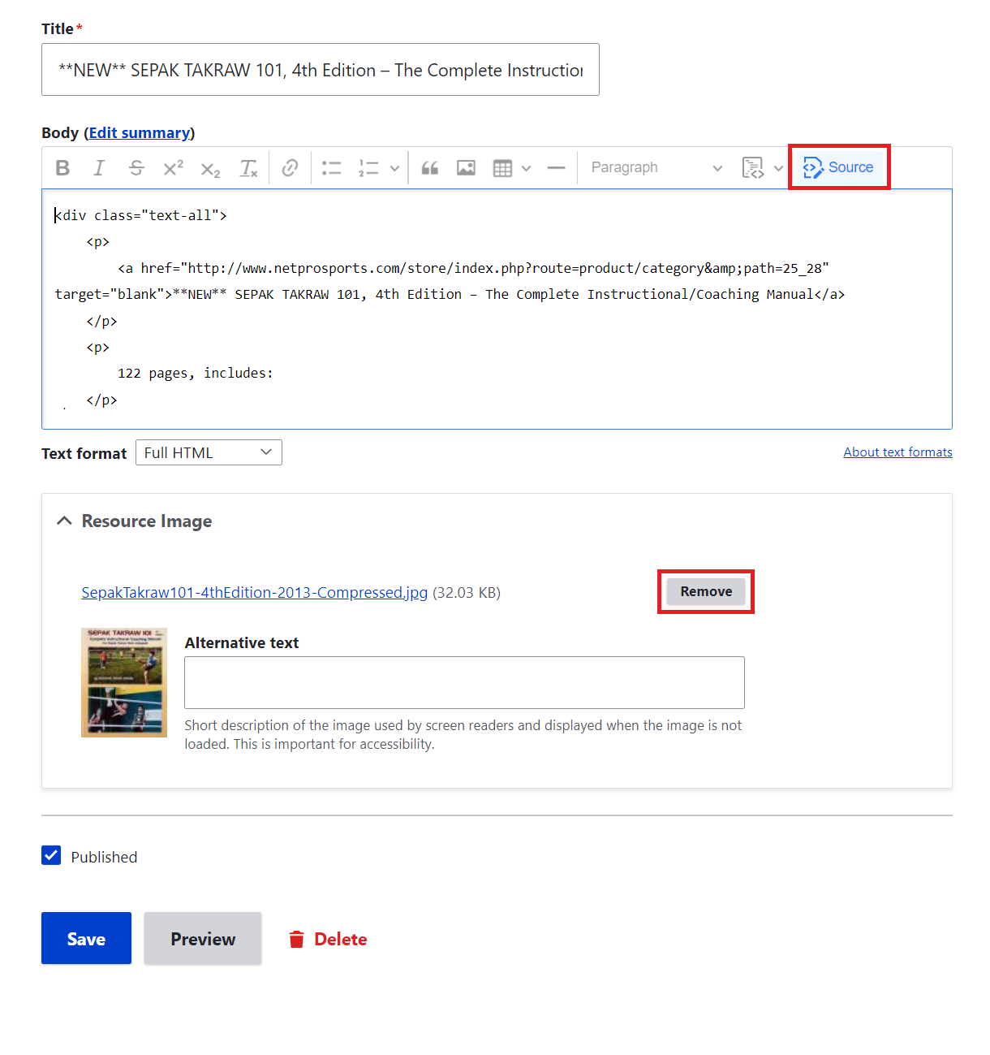

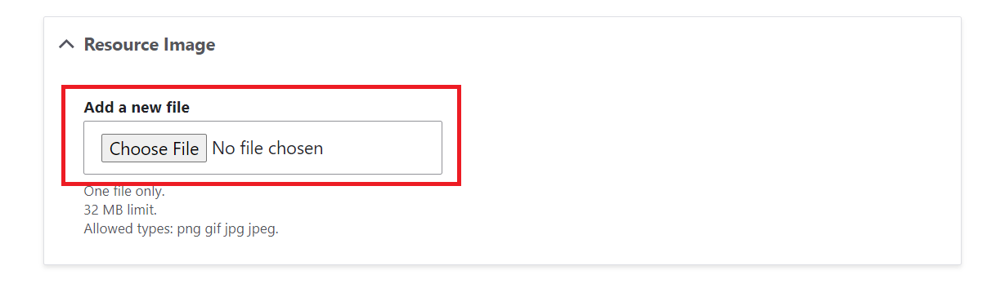

Step 10: After choosing Pictures click **save** button

**How to Add New Resources:**

Step 1: Click The **Content** Option in header section



Step 2: After clicking Add content below page will be open

Step 3: In content type section you would choose Slide

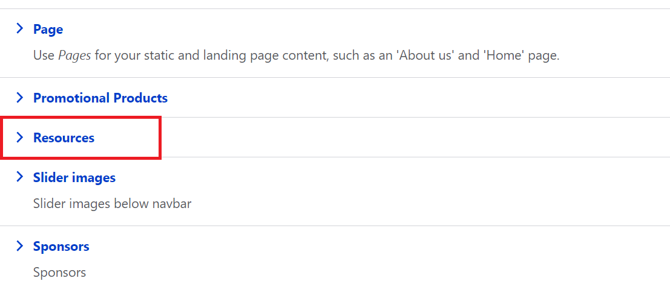

Step 4: As above image you want to click Resources option

Step 5: After choosing Resources option below Page will be open

Step 6: Enter title name in title section, and after that in body section enter the blogs that you want to change or add in paragraph tag

(Note: If you are adding new blogs please validate existing directors once and refer html classes and tags.)

Step 7: To add a resource image, After that click **choose file** in resource image section after click **choose file** button to add a new pictures, after that it will redirected to your PC and choose pictures that you want to add

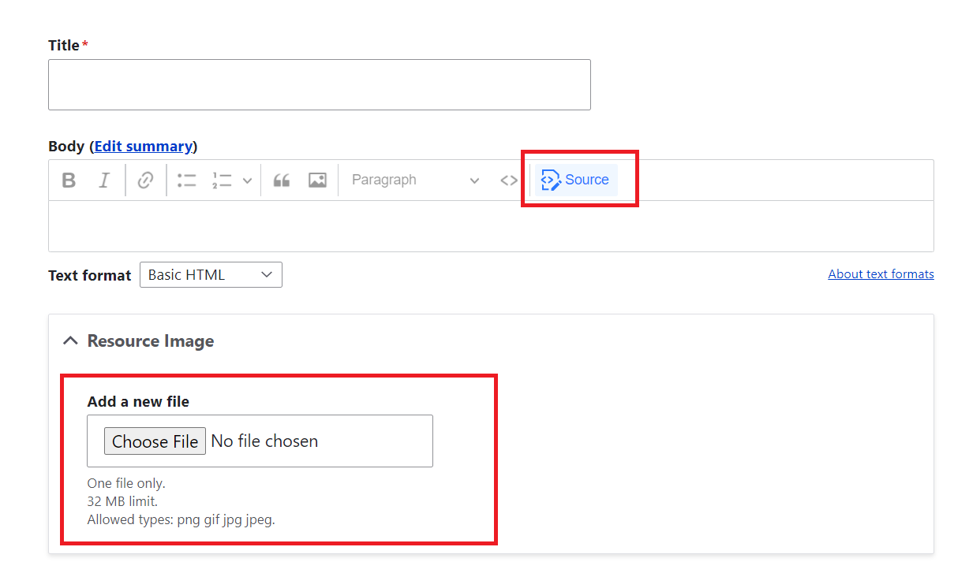

Step 8: After choosing Pictures click **save** button

**How to modify Promotional products:**

Step 1: Click The **Content** Option in header section



Step 2: After clicking Add content below page will be open

Step 3: Select **Promotional products** from drop down list

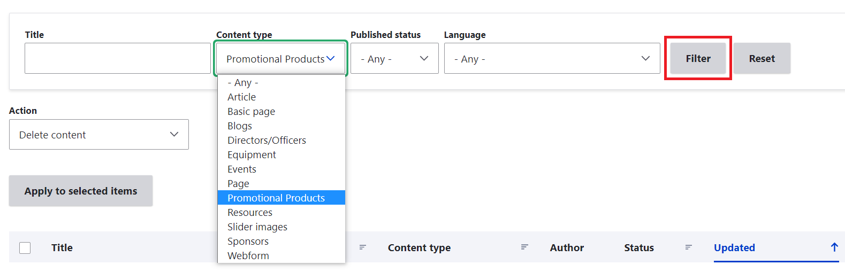

Step 4: After clicking filter button the list of available resources is shown like below image

Step 5: Choose which product you want to edit and click Edit button in the right corner

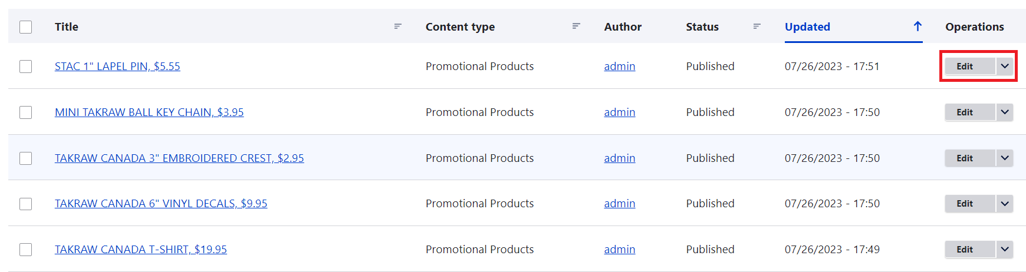

Step 6: Enter title name in title section, and after that in body section click **source** enter the product that you want to change or add in paragraph tag

(Note: If you are adding new blogs please validate existing directors once and refer html classes and tags.)

Step 7: To add a promotional product image, click **remove** button in right corner, then **choose file** in promotional product image section after click **choose file** button to add a new pictures, after that it will redirected to your PC and choose pictures that you want to add

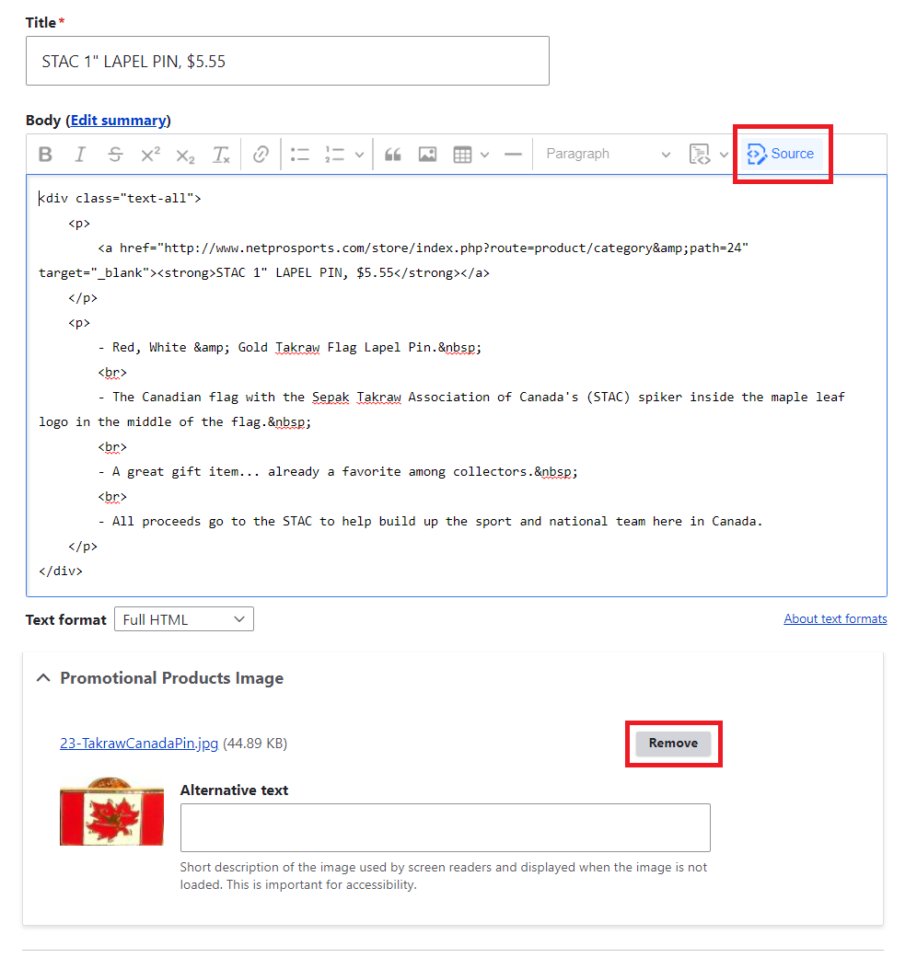

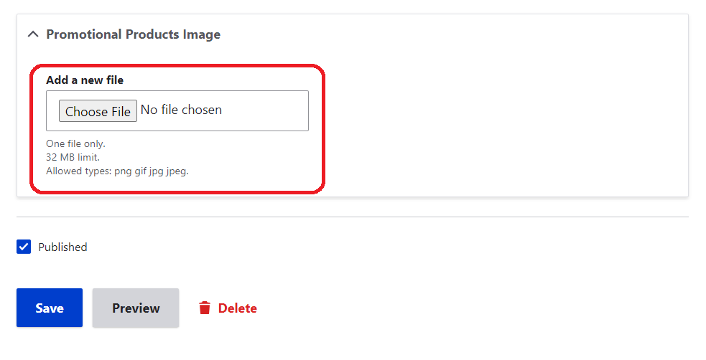

Step 8: After choosing Pictures click **save** button

**How to Add New Promotional products:**

Step 1: Click The **Content** Option in header section



Step 2: After clicking Add content below page will be open

Step 3: Select **Promotional products** from list

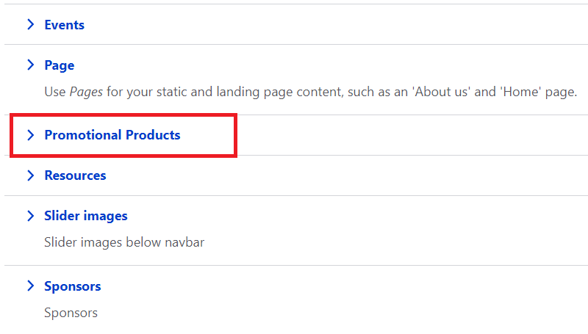

Step 6: Enter title name in title section, and after that in body section click **source** enter the product that you want to change or add in paragraph tag

(Note: If you are adding new blogs please validate existing directors once and refer html classes and tags.)

Step 7: To add a promotional product image, click **choose file** button to add a new pictures, after that it will redirected to your PC and choose pictures that you want to add

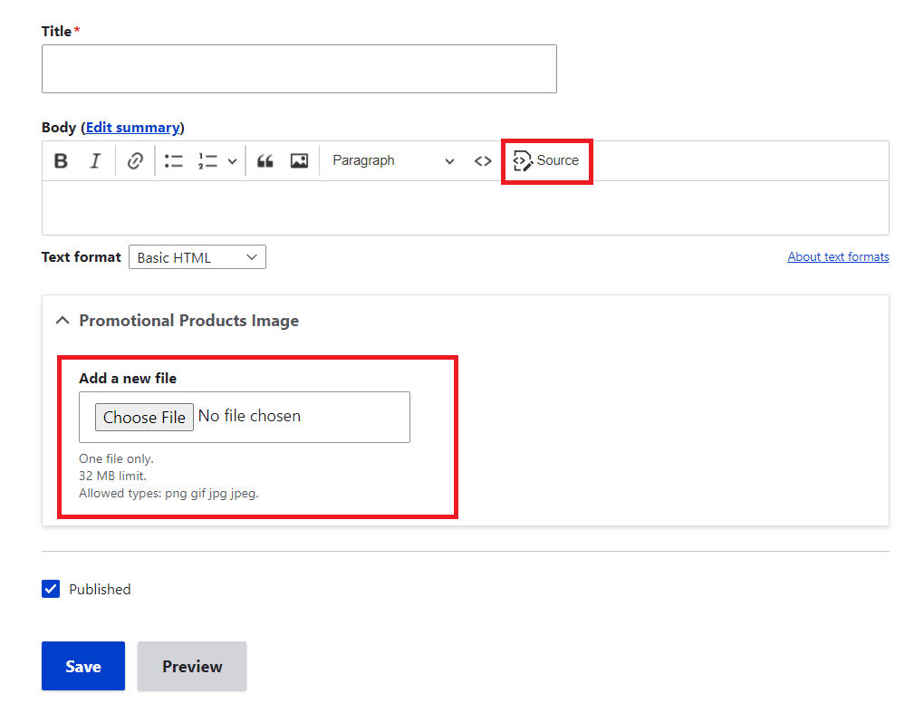

Step 8: After choosing Pictures click **save** button

**How to Modify Equipment:**

Step 1: Click The **Content** Option in header section



Step 2: After clicking content below page will be open

Step 3: Select **Equipment** from drop down list

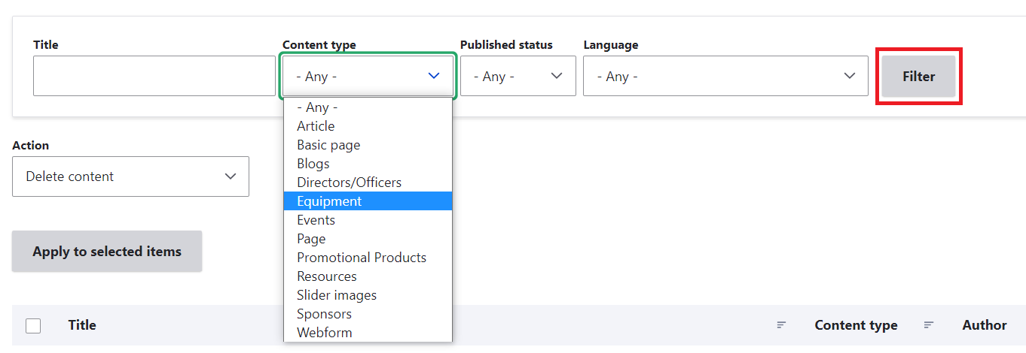

Step 4: After clicking filter button the list of available resources is shown like below image

Step 5: Choose which product you want to edit and click Edit button in the right corner

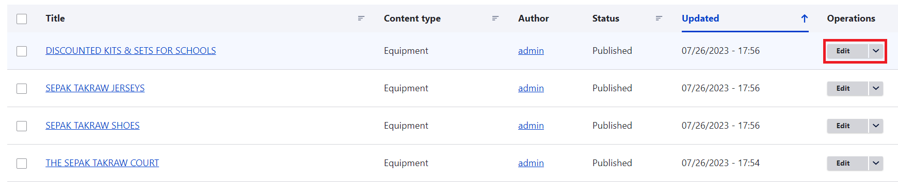

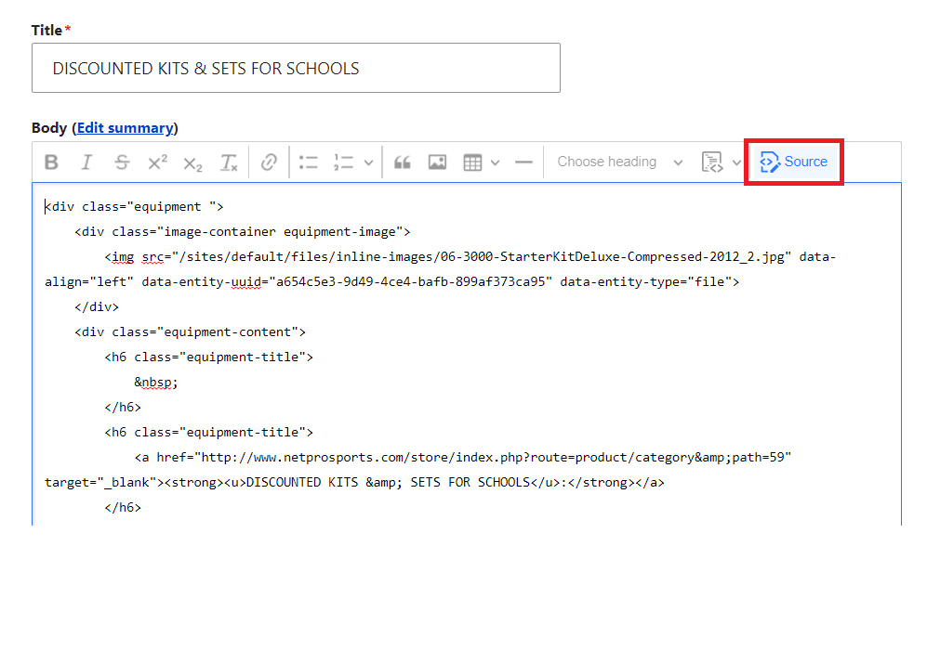

Step 6: Enter title name in title section, and after that in body section click **source** enter the blogs that you want to change or add in paragraph tag

(Note: If you are adding new blogs please validate existing directors once and refer html classes and tags.)

Step 7: After choosing Pictures click **save** button

**How to Add Equipment:**

Step 1: Click The **Content** Option in header section



Step 2: After clicking content below page will be open

Step 3: Select **Equipment** from drop down list

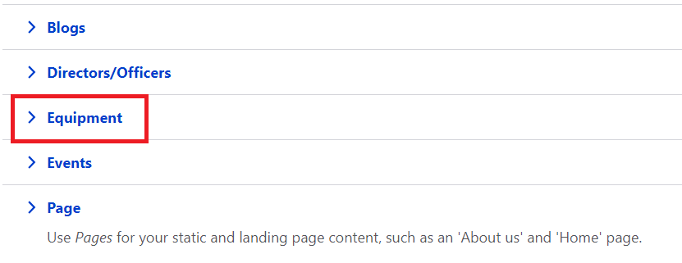

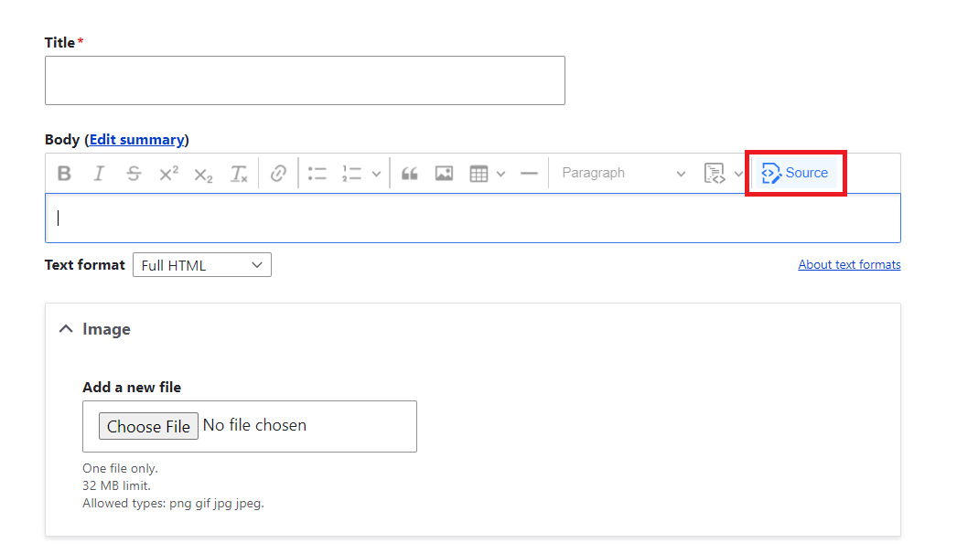

Step 4: Enter title name in title section, and after that in body section click **source** enter the blogs that you want to change or add in paragraph tag

(Note: If you are adding new blogs please validate existing directors once and refer html classes and tags.)

Step 5: To add a image, click **choose file** button to add a new pictures, after that it will redirected to your PC and choose pictures that you want to add

Step 7: After choosing Pictures click **save** button

**How to add custom block library:**

Step 1: Click The **Structure** Option in header section

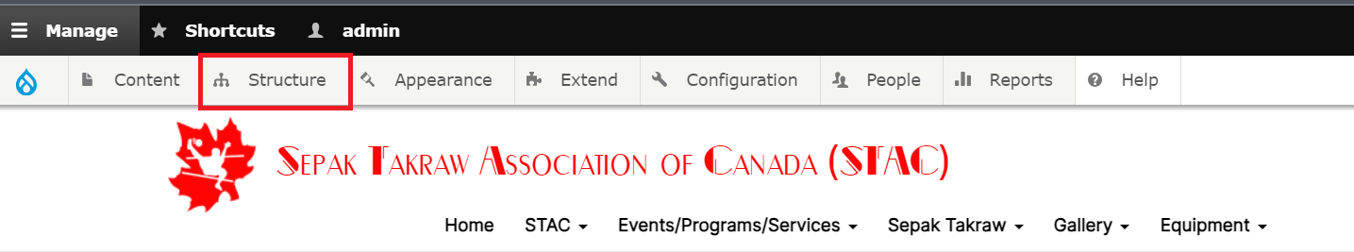

Step 2: After clicking structure below page will be open

Step 3: Select **Block Layout** from drop down list

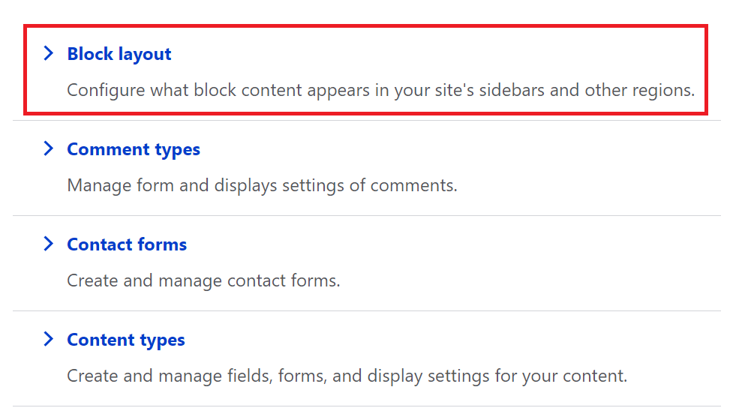

Step 4: After clicking structure below page will be open, then click **Custom block library**

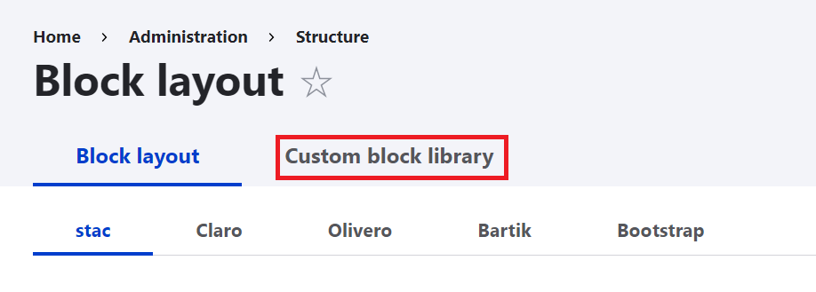

Step 5: After clicking structure below page will be open, Click **Add custom block**

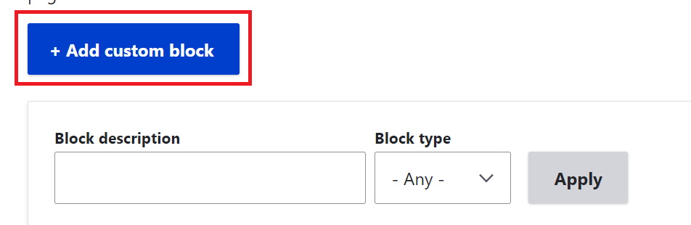

Step 6: After clicking add custom block below page will be open,

Step 7: Enter description in block description, and after that in body section click **source** enter the blogs that you want to change or add in paragraph tag

(Note: If you are adding new blogs please validate existing directors once and refer html classes and tags.)

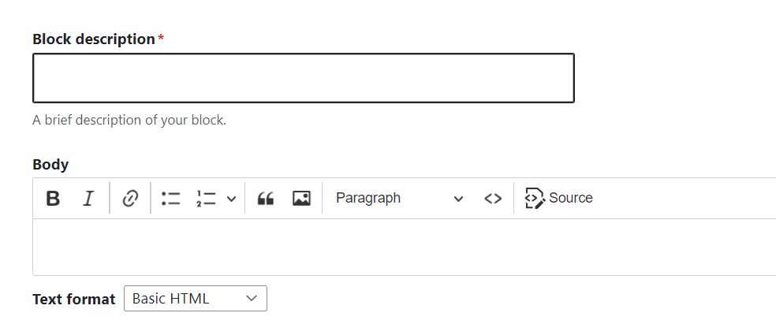

Step 8: After completing, click **save** button

**How to Modify Layout:**

Step 1: In admin panel below header section you want to choose **layout**

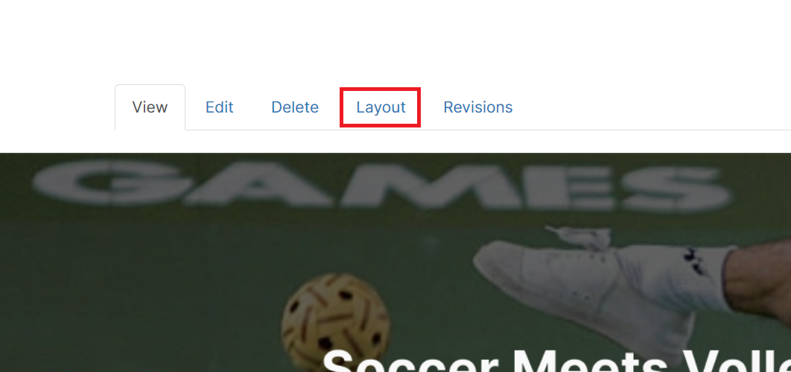

Step 2: After below page will be shown

Step 3: If you want to add blogs click **Add block** in footer area

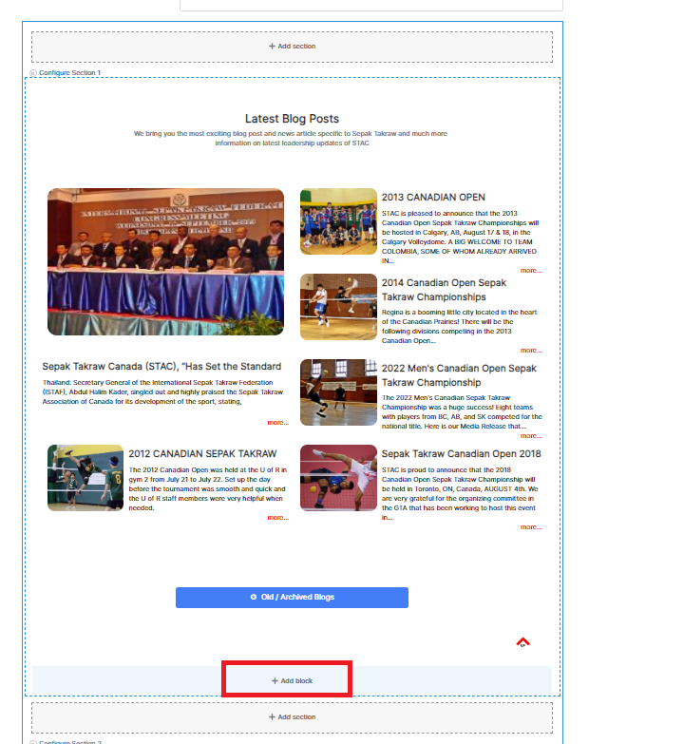

Step 4: After the below page will be shown,in search box search custom block name that you created

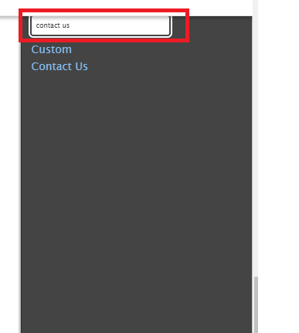

Step 5: if you want to display title in page you want to mark tick in the box and click **Add block** button

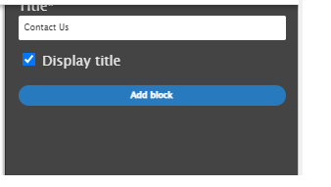

Step 6: If you want to move blogs click **pencil** icon in the right corner, click **move** from list

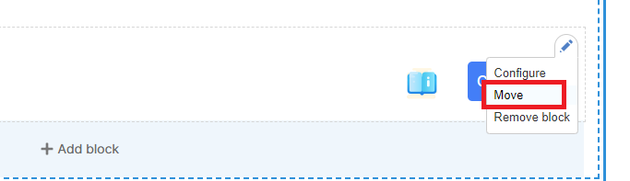

Step 7: After clicking move button below page will be shown, then drag which blocks you want in a particular order, click **Move**

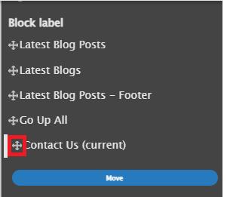

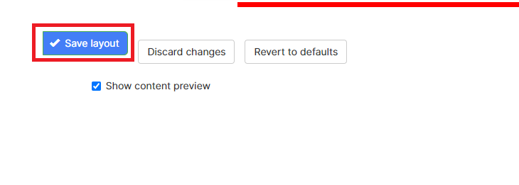

Step 8: After that click **save layout** button